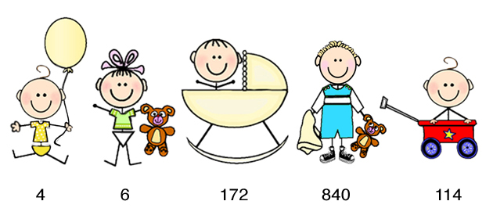

Mommy & Me Program

Scarborough Presbyterian Children’s Center is happy to announce the return of our Mommy & Me Program for children ages 9 to 36 months. This is a wonderful opportunity for children to gain independence and a sense of self confidence, in a safe and comfortable environment.

The Mommy & Me Program offers a gentle and nurturing way to introduce children to school, exposing them to classroom routines and materials. The Mommy & Me Program is a wonderful opportunity, not only for children to socialize, but also for parents to meet and socialize with other parents from the community.

Through play, children explore their world, learn to get along with others, test their skills and muscles, try out new ideas and begin to feel confident enough to take risks in trying different activities and learning new things. Specifically, group play contributes to the development of language, social skills, problem solving and imagination.

At SPCC, we recognize the importance of introducing young children to the routines of school while still having a loved one close by. To insure that children and parents/caregiver receive individual attention, we have a staff to child ratio of 1 staff member to every 4 children. Parents can feel at ease introducing their little one to school in our safe, supervised and specially designed classroom with our experienced, warm and nurturing staff.

Classes are held on Wednesday afternoons:

12:30 – 1:30 pm for children 18 – 36 months old
2:00 – 3:00 pm for children 9 – 18 months old

Semester 1: $45.00
December 1, 8, 15

Semester 2: $240.00
January 12, 19, 26, February 2, 9, 16, March 2, 9, 26, 23, 30, April 6, 13, 27, May 4, 11

To register or for more information, please call 914-941-0025.

